

DEPARTMENT OF COMPUTER SCIENCE AND ENGINEERING
23CSE304 Embedded Systems Laboratory
Activity Sheet

Activity Name: Seven Segment Display Interfacing

Name of Student: | Agneay B Nair
Registration No.: | CH.SC.U4CSE24102
Activity Date: | 28.7.26
Submission Date: | 28.7.26

Assessment Rubrics:

Component | Maximum Marks | Marks Allotted
Program | 3
Output | 4
Viva | 2
Timely Submission | 1
Total | 10

Faculty In-charge

Write an embedded C program for ARM architecture to interface Seven Segment Display. Debug and verify the program using IDE on a development computer system.
CODE:
#include<stdio.h>
#include<LPC213x.h>

unsigned char digit[10] = {
0x3F, // 0
0x06, // 1
0x5B, // 2
0x4F, // 3
0x66, // 4
0x6D, // 5
0x7D, // 6
0x07, // 7
0x7F, // 8
0x6F, // 9
};

void delay(int n){
int i,j;
for(i = 0;i<n;i++)
for(j=0;j<1000;j++);
}

int main(){
int i;
PINSEL0 = 0x00000000;
IODIR0 |= 0xFF;

while(1){
for(int i = 0;i<10;i++){
IOCLR0 = 0xFF; // Clear Previous digit
IOSET0 = digit[i]; // Display digit

delay(500);
}

}
}

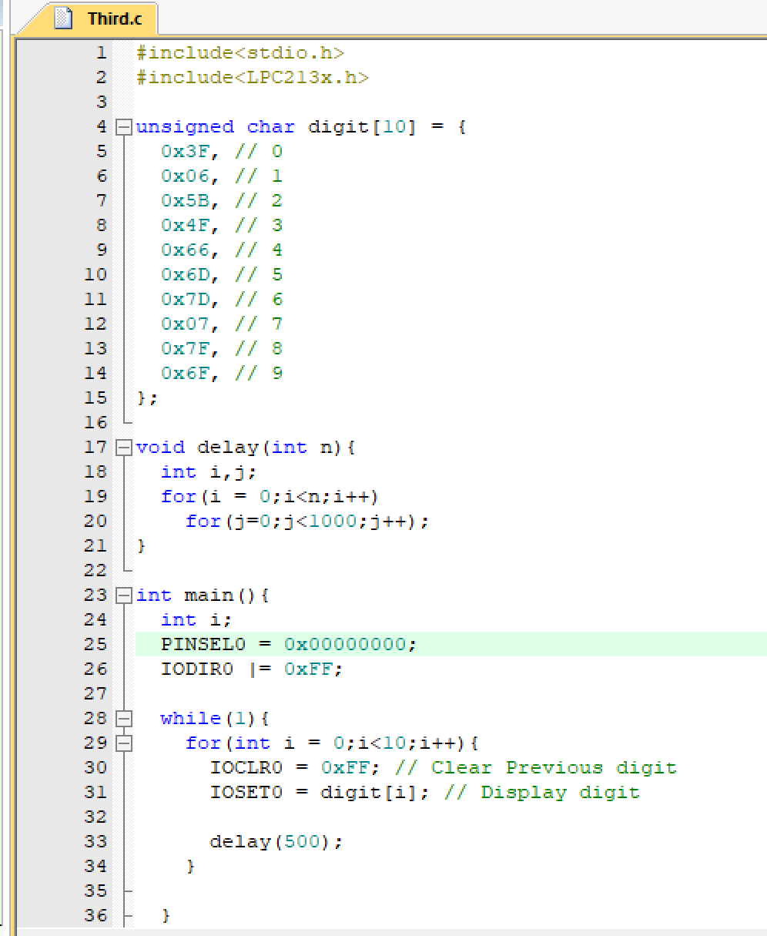
OUTPUT:
